SKILL

TASK-1 :

- Install/Verify Linux

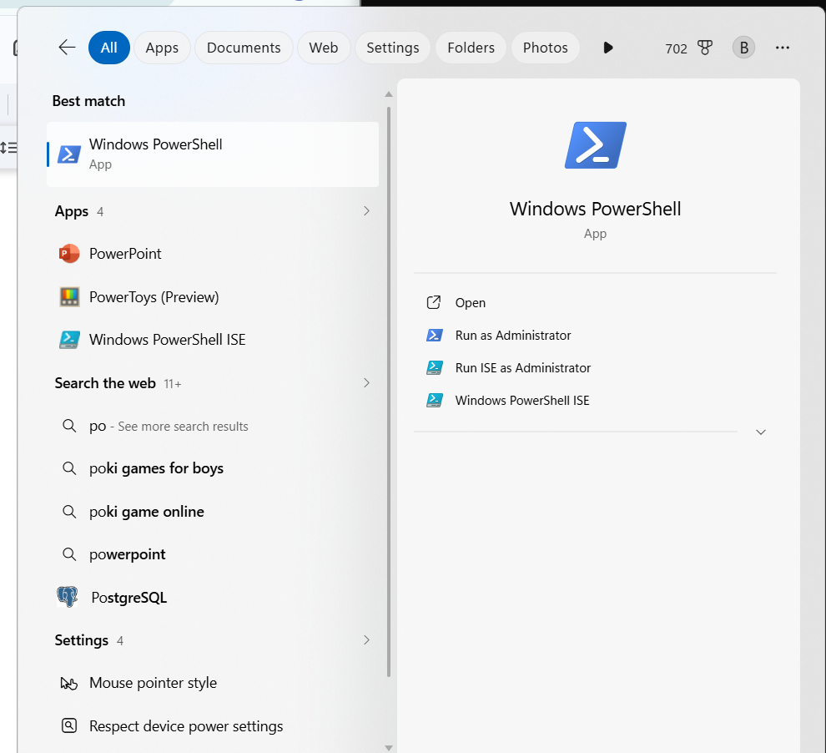

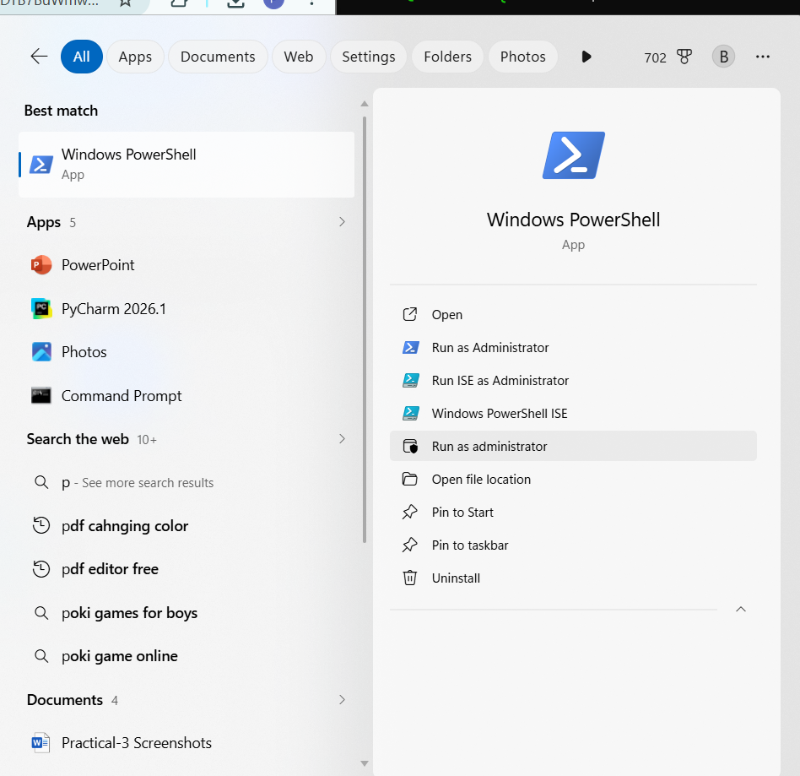

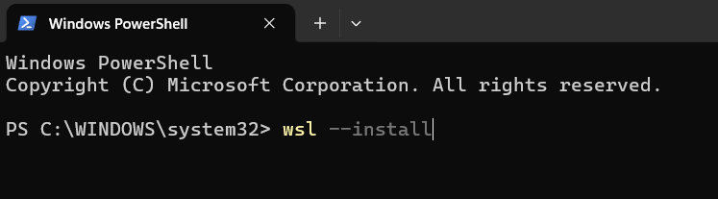
1. Enter your username
2. Create a password
3. Confirm the password
4. Wait for Ubuntu to finish setup

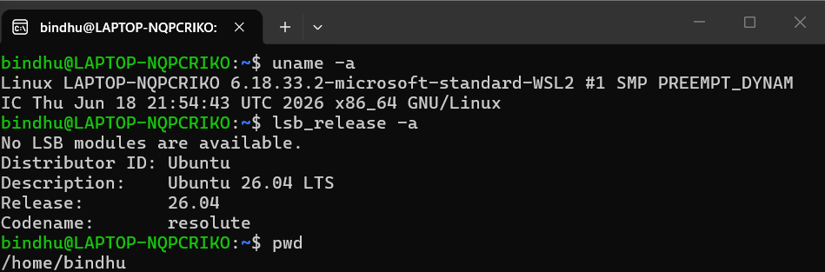
- Configure gcc

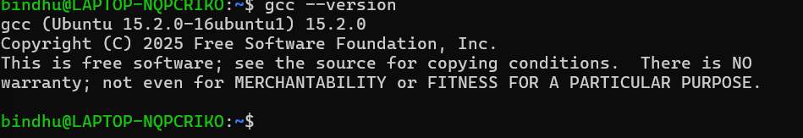
- Install gcc

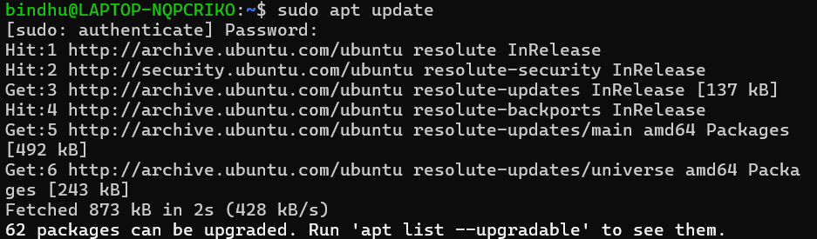
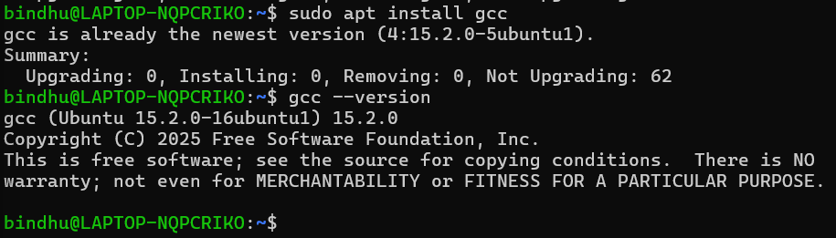
Create C program

4.Compile the program

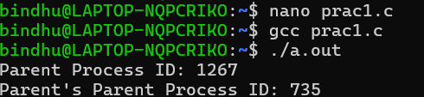

5. Git repository
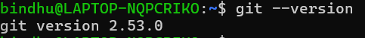

6. Shell architecture
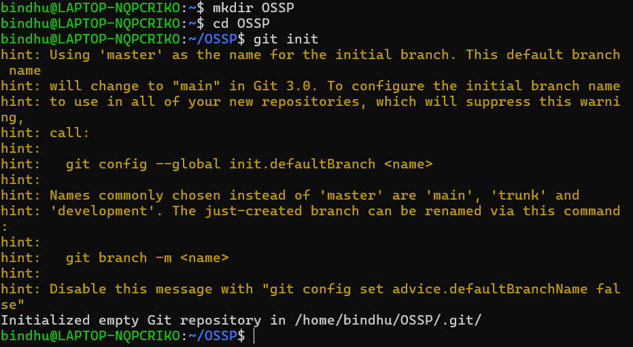
7. Create project structure
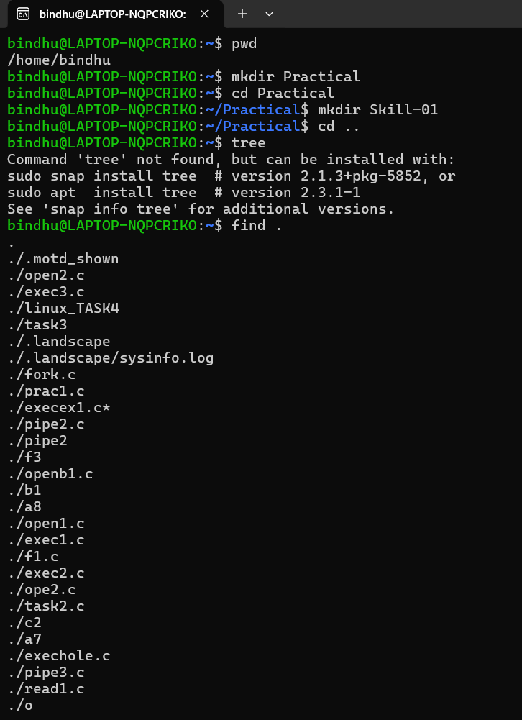
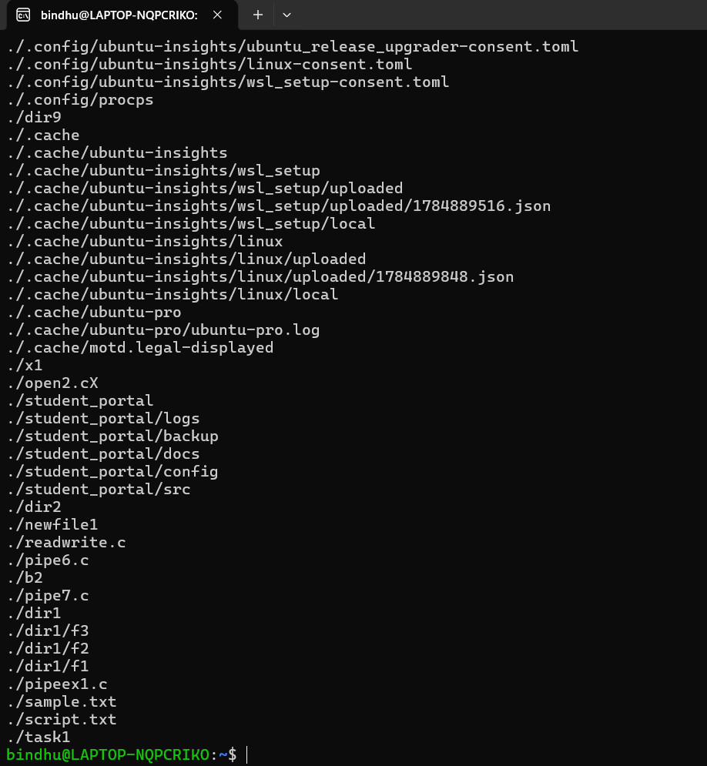
8.Build Initial Makefile
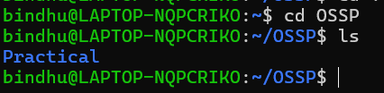
9.Process abstraction
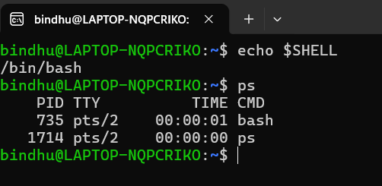
10. Create fork()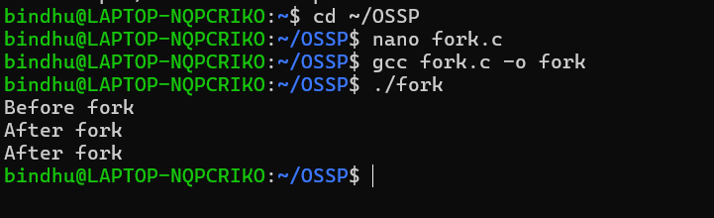
11. exec() family
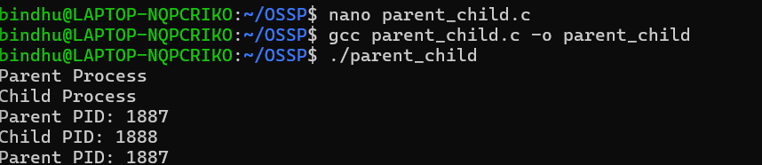
12.Parent-child relationship
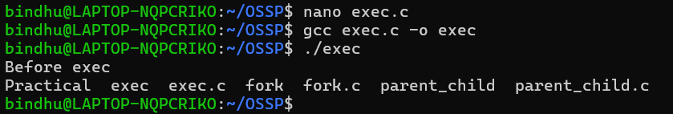
13.Process tree
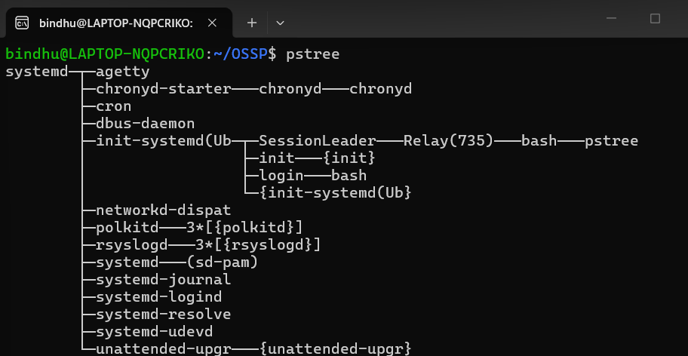
14.System call tracing
